RTO Code: 41413 | CRICOS: 03989C

Student ID | ​14780735
Student Name | ​Sahilpreet singh
Assessor Name | Ankush Takyar

Assessment 1
Knowledge Test

CPCCCA3010 Install windows and doors

Assessment Submission Details
Type of Assessment
This summative assessment will enable your Assessor to make a judgement of competency based on the submission of your completed assignments against the requirements of this unit of competency.
Assessor Instruction
The Assessment Benchmark developed for each unit of competency is the evidence criteria used to judge the quality of performance (i.e., the assessment decision-making rules). Assessors must use these benchmarks to make judgement on whether competency has been achieved and to determine if the participant has performed to the standard expected to meet unit requirement and learning outcomes. Competency results for each unit are recorded in the assessment checklist.
- Time allowed: As scheduled in-class roll
- Assessment conditions: Under supervision
- Open book (use of learning materials permitted for any part of the assessment)
- Students are to undertake all parts of the assessment
- Issue documentary resources for task e.g., worksheet/job card/plans/specifications
- Students are entitled to three attempts at each part of the assessment; students will only be retested in those parts of the assessment of which a satisfactory result was not demonstrated in any attempt.
This checklist is to be used when assessing the students in this task. This checklist is to be completed for each student.
Reasonable Adjustment
VIC will allow flexibility in relation to the way in which each unit is delivered and assessed based on the student’s requirement. The following are the reasonable adjustments for this unit:
Reasonable adjustments for this unit
Assistance of a learning support teacher for LLN issues
Modifications to physical environment, e.g., wheelchair access
Changes to course design, e.g., verbal questioning with assessor to write answers provided by student
Changes in lecture schedules and arrangements, e.g., relocating classes to an accessible venue
Modifications to computer equipment in the computer lab

Student Declaration
- I acknowledge the assessment process has been explained and agree to undertake assessment.
- I am aware of the RTO’s appeals process, should the need arise.
- I also understand that I must be assessed as ‘satisfactory’ in all parts of the assessment to gain a competent result for this unit of competency.
- I declare that the work contained in this assessment is my own, except where acknowledgment of sources is made.
- I understand that a person found responsible for academic misconduct will be subject to disciplinary action as described in the refer to student handbook.
Student Assessment Agreement
Make sure you read through the assessment before you fill out and sign the agreement below.
If there is anything that you are unsure of, consult your assessor prior to signing this agreement.
Have you read the assessment requirements for this unit? | ☐ Yes | ☐ No
Do you understand the requirements of the assessments for this unit? | ☐ Yes | ☐ No
Do you agree to the way in which you are being assessed? | ☐ Yes | ☐ No
Do you have any specific needs that should be considered? | ☐ Yes | ☐ No
If you have ticked yes to special need, explain these in the space below.

Signature | sahil
Date Of Submission | 9/23/26

Summative assessment
Summative assessments are the major activities designed to assess the learner’s skills, knowledge, and performance, as required to show competency in this unit. These activities should be completed after finishing the Learner activity book. These should be completed as stated under the trainer/assessor instructions.
Skills, knowledge, and performance may be termed as:
Skills – skill requirements, required skills, essential skills, foundation skills
Knowledge – knowledge requirements, required knowledge, essential knowledge, knowledge evidence
Performance – evidence requirements, critical aspects of assessment, performance evidence.

Questions (Q & A)
The questions assessment is designed to be a written questionnaire where the learner completes a series of questions to confirm their competency for all of the required knowledge in the unit of competency.

Objective
To provide you with an opportunity to show you have the required knowledge for this unit.
The answers to the following question will enable you to demonstrate your knowledge of:
- Plan and prepare.
- Install window units.
- Prepare internal and external door openings, and construct and fix jamb.
- Install door.
- Install cavity door and door unit.
- Clean up.

Assessment
Provide answers to all the questions below:
Question 1
Answer the following questions:
1.1. What are Australian building standards?
1.2. What are the requirements for compliance and conformance according to National Construction Code (NCC)?
1.3. How can you differentiate between NCC and Australian standards?

1.4. What are the compliance requirements specificed in AS2688 Timber and composite doors?

1.5. What are the compliance requirements specificed in AS2047 Windows and external glazed doors in buildings?

1.6. Wat are the compliance requirements for installation of windows as per the Australian Window Association - An Industry Guide to the Correct Fixing of Windows and Doors?

Answer

Question 2
Discuss the workplace quality policies and standards relevant to installing windows and doors
Answer

Question 3
Discuss the safety requirements related to installation of doors and windows.
Answer

Question 4
Answer the following questions:

4.1. What are the flashing requirements relevant to installing windows and doors
4.2. Explain the installation techniques relevant to installing windows
4.3. Explain the installation techniques relevant to installing doors

Answer

Question 5
Answer the following questions:

5.1 Explain the key features of plans and drawings in carpentry work

5.2 Explain the purpose of the following plans and drawings
- Site Plan
- Cross Section
- Elevation

5.3. Discuss the following specifications related to installation of doors and windows Standard sizes
- Tolerances
- Material
- Position of holes
- Fixing screws and lugs
Answer

Question 6
Document two (2) characteristics, uses and limitations each of the following tools and equipment: -
S. No | Tool | Characteristics | Uses | Limitations
1 | Hammer
2 | Power drills
3 | Power saws
4 | Measuring tapes

Answer

Question 7
Discuss the processes for setting out windows and doors
Answer

Question 8
8.1. Calculate the quantity of material for installing doors by taking dimensions given in figure into consideration.
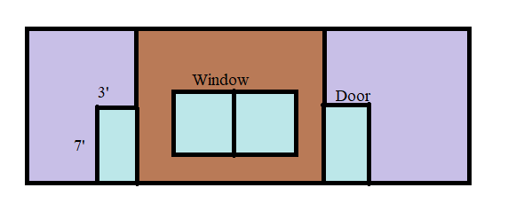
8.2. Write the steps for calculating the quantity of material for installing windows

Answer

Question 9
Prepare a list of any seven (7) materials use for installing windows and doors
Answer

Question 10
10.1. Describe the various types of doors in 1-2 sentences each:
- Flush panel door
- Framed and panelled door
- Glazed door
10.2. Explain the hinged doors units, including the following
- standard doors
- sliding,
- flywire,
- combination window and door units,
- door sidelight units (glazed or unglazed)
- internal doors
10.3 Describe the following components of doors
- jambs
- stiles
- sills
Answer

Question 11
Explain the following the door furniture
- flush pulls
- latches and deadlocks
- push plates and closers
- handles and locks
Answer

Question 12
12.1. Mention the name, material, characteristics and uses of the type of doors given in column 2 of the table.
S. No | Type of doors | Name | Material | Characteristics | Uses
1 | 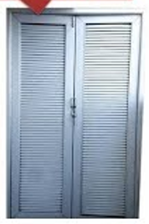
2 | 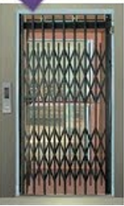
3 | 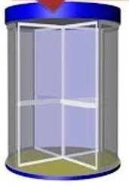
4 | 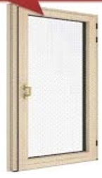

12.2. Mention the name, material, characteristics and uses of the type of windows given in column 2 of the table.
S. No | Type of windows | Name | Material | Characteristics | Uses
1 | 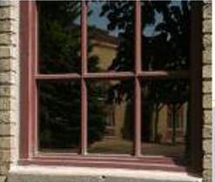
2 | 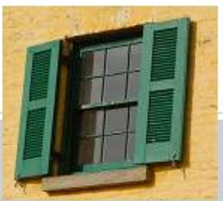
3 | 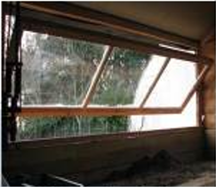
4 | 
5 | 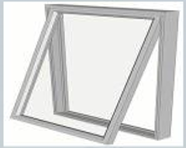
6 | 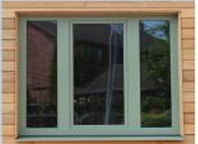

End Of Assessment

